

Systems Development: Object Oriented Programming

(H172 35)

Introducing Classes

GradeBook Walkthrough

Step 2 – declaring a method with a parameter

Sometimes the task to be performed by a method requires additional information to help perform the task, this additional information is known as a parameter. A method can require one or more parameters to help with the task.

A method **call** supplies values, called *arguments*, for each of the methods parameters.

We are going to extend our previous GradeBook class DisplayMethod to display the course name as part of the welcome message. The new DisplayMessage method requires a parameter that represents the course name to output.

Update the GradeBook.cs class as follows to add a parameter to the Display Message method:

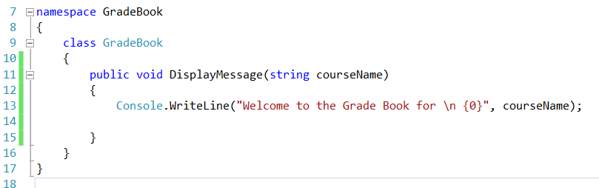

And now update the GradeBookTest.cs to pass an argument to the DisplayMessage method:

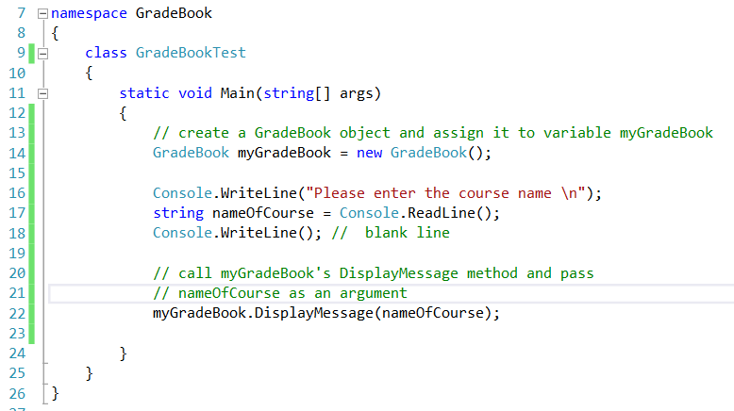

Result:

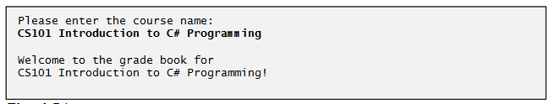

The variable nameOfCourse in parentheses is the argument that’s passed to method DisplayMessage so that the method can perform its task. Variable nameOfCourse (in Main) becomes the value of DisplayMessage’s parameter courseName (line 11).

Each parameter is declared as a variable with a type and identifier in the parameter list. Empty parentheses following the method name indicate that a method does not require any parameters. In Fig. DisplayMessage’s parameter list (line 11) declares that the method requires one parameter. Each parameter must specify a type and an identifier. In this case, the type string and the identifier courseName indicate that method DisplayMessage requires a string to perform its task. At the time the method is called, the argument value in the call is assigned to the corresponding parameter (in this case, courseName) in the method header. Then, the method body uses the parameter courseName to access the value.

**Note**:

Normally, objects are created with *new*. One exception is a string literal that’s contained in quotes, such as “hello”. String literals are *string* objects that are implicitly created by C# the first time they appear in the code.